Current Events- EXCEEDING Name:
Ms. Bennett Date:
 | Article #1: The main article you write about | Article #2: Used for comparison (the last task)
Name of Article:
Name of Newspaper/
Website/ Magazine
Date of Publication:
Questions: Please answer all of the following questions using all the space provided. If you require additional space, please attach on loose-leaf. Please incorporate 2 quotes from the article somewhere in your answer. If you cannot “dig deeper” into your article, then perhaps you should select another article. For example, with the Motorcycle Road Rage article we all discussed, to dig deeper you should question safety, police presence, etc.

Tasks: Check boxes when you complete the tasks.

� Summarize the article in your own words. You should include the 5W’s: Who, What, When, Where, and Why.

� What is your “gut” reaction to the article?

� Does the information in this article affect you? Who does it affect and how?

� What is something you learned from the article?

� How does this article connect to others you have read or your own life?

� What are additional questions you have about this article? Include who you would direct them to- either me, the newspaper, or someone featured in the article.

� Did you include two quotes? Quotes should be introduced with a sentence and also be explained/elaborated on following the quote.

� How does this article relate to economics?

� Research this current event and find another news source that covers this current event. Is the event covered differently? Do the authors have different points of view towards the event? Explain.
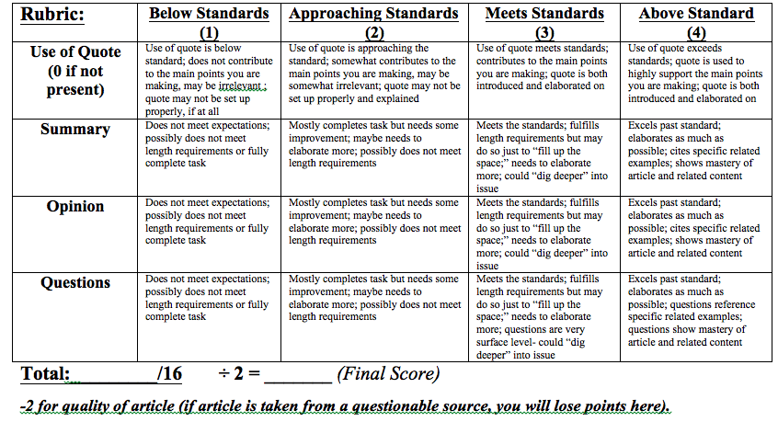  Next Steps: | CC Standards:  Reading: 1. Cite specific textual evidence to support analysis of primary and secondary sources, connecting insights gained from specific details to an understanding of the text as a whole.  2. Determine the central ideas or information of a primary or secondary source; provide an accurate summary that makes clear the relationships among the key details and ideas.  6. Evaluate authors’ differing points of view on the same historical event or issue by assessing the authors’’ claims, reasoning, and evidence.  Writing: 4. Produce clear and coherent writing in which the development, organization, and style are appropriate to task, purpose, and audience.
____________________________________________________________________________________________________________________________________________________________________________________________________________________________________________________________________________________________________________________
__________________________________________________________________________________________________________________________________________________________________________________________________________________________________________________________________________________________________________________________________________________________________________________________________________________________________________________________________________________________________________________________________________________________________________________________________________________________________________________________________________________________________________________________________________________________________________________________________________________________________________________________________________________________________________________________________________________________________________________________________________________________________________________________________________________________________________________________________________________________________________________________________________________________________________________________________________________________________________________________________________________________________________________________________________________________________________________________________________________________________________________________________________________________________________________________________________________________________________________________________________________________________________________________________________________________________________________________________________________________________________________________________________________________________________________________________________________________________________________________________________________________________________________________________________________

