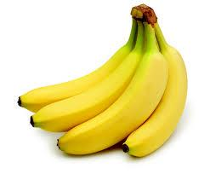
Bananas, Flowers, and Coffee! Period 6

Directions: Open the QR Code Reader on your phone/device and hover it over the QR codes below to complete the activity.

Step 1: Pretest: Activate the QR Code below and complete the Google Form.
https://docs.google.com/a/mhvpschool.com/forms/d/17rLlGDXFF5TwCuxKOqhmu3SL_EztgYPz27T7ogo7CRM/viewform

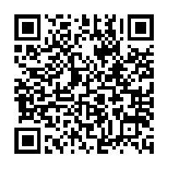

Step 2: Article: Activate the QR Code below and read the worksheet, “The Mystery of Bananas”. https://drive.google.com/file/d/0B6BfflJgcq8eQ1EyaGdFbFFXY1E/view?pli=1
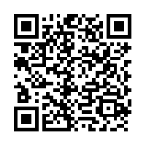

Step 3: Response to the Article: Activate the QR Code below. Padlet, the Digital Corkboard tool, will open. Read the prompt and respond to it by double clicking the workspace and typing your response.
http://padlet.com/ms_bennett1/bananasperiod6

