Bangladesh Factory Fire Article Name:
Economics, Ms. Bennett

Pre-Reading Questions: (Please answer on loose-leaf)
1. Should you care about the health and safety of the people who make your clothing?
2. Do you ever question where and how your clothes are made?
3. Are you willing to pay higher prices for your clothing to improve working conditions in places like Bangladesh and Pakistan?
4. What responsibility do you think clothing brands and United States retailers have to ensure that the workers who make their products are safe?

Step 1: Annotate Article
 | 1 | 2 | 3
Underlining, Circling, Highlighting Passages | *Missing in most passages  *Underlined/ highlighted portions are too long | *Present in some passages  *In some cases, too much information is highlighted or underlined | *Present in all passages  *Are brief and specific, bringing focus to the most important points
Notes in the Margin | *Per page, the text includes less than 2 notes in the margin | *Per page, the text includes between 2-4 notes in the margin | *Per page, the text includes at least 5 notes in the margin, ranging from paraphrasing/reaction to the text, to commenting on it.
Questions | *No questions provided | *Per page, there is 1 question  *Per page, there are 2 questions that are basic and not thought-provoking. | *Per page, there are 2 questions, at least one of which that is thought-provoking that you could ask the class (use the sentence starters to help with this, Level 3/4 on DOK Question Starters)
Self Assessment:_____________ _/3 (average of scores above)
Because…

Teacher Assessment: ________/3

Rubric for Short Answer Questions
Approaching (1) | Meeting (2) | Exceeding (3)
Questions are SOMEWHAT answered completely, with proper grammar and in complete sentences. Answers are SOMEWHAT thoughtful but further explanation is RARELY given. Evidence/examples may/may not be given (when asked) to support your argument. Assignment may be incomplete. | Questions are MOSTLY answered completely, with proper grammar and in complete sentences. Answers are MOSTLY thoughtful and further explanation is SOMETIMES given, or is missing. Evidence/examples may/may not be given (when asked) to support your argument. | Questions are answered completely, with proper grammar and in complete sentences. Answers are thoughtful and further explanation is given. Evidence/examples are given (when asked) to support your argument.
Self Assessment:______________/3
Common Core Standards Addressed:

Reading:
1. Cite specific textual evidence to support analysis of primary and secondary sources, connecting insights gained from specific details to an understanding of the text as a whole.
2. Determine the central ideas or information of a primary or secondary source; provide an accurate summary that makes clear the relationships among the key details and ideas.

Writing:
4. Produce clear and coherent writing in which the development, organization, and style are appropriate to task, purpose, and audience.

Because…

Teacher Assessment:__________/3
Comments:

Deadly factory collapse puts cost of cheap clothes on trial
By Max Fox
05.13.13
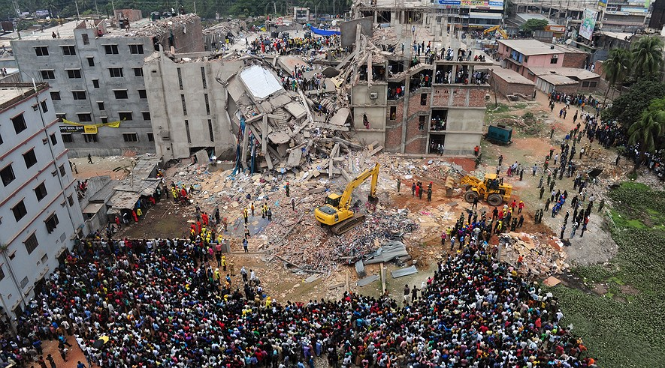
Bangladeshi volunteers and rescue workers are pictured at the scene after an eight-story building collapsed in Savar, on the outskirts of Dhaka, on April 25, 2013. Photo: AFP/Getty Images
Weeks after a clothing factory collapsed in Bangladesh, rescuers are still pulling out bodies. Meanwhile, lawmakers and clothing companies are asking themselves hard questions: what is the human cost of cheap clothes?
The eight-story Rana Plaza factory complex crumbled on April 24. Nearly 3,000 workers got trapped inside. More than 1,100 were killed. It is the worst-ever accident in the clothing business. Reports from the disaster area have been dramatic.
A baby boy was born under the rubble just after the collapse. The baby's 26-year-old mother survived the falling concrete, mortar and bricks.
Another worker, Sonia Akthar, was sewing a shirt when the ceiling collapsed on her, Al-Jazeera reported. Her leg became trapped under heavy concrete. Rescuers were forced to take off her leg to save her. Other workers were luckier, and acted heroically to save others. Rescuers pulled out Reshma Begum after 17 days. The 19-year-old survived on four packets of cookies she had in her backpack and some water.

Owner Arrested Trying To Flee
The building owner was Mohammed Sohel Rana. He was arrested as he tried to flee the country. He is a local politician, but was also known as a neighborhood gangster. Police, engineers and workers warned him that the building's pillars were near breaking. Workers say Rana ordered them back inside the factory. The building crumbled the next day.
On Tuesday, survivors protested near the factory. They blocked traffic, demanding their pay. The government has agreed to improve the factories and its building inspections. But labor experts say the government is part of the problem. In the past, factory owners could just pay officials to look the other way. That is why so many safety hazards were ignored.
Bangladesh needs garment factories. Clothes are the country’s top export. It is the world's second-largest clothing producer. Almost half the population of 150 million lives on less than $1 a day. Factories create much-needed jobs, especially for women. But about half of the nation's factories are unsafe, said Kalpona Akter, who represents workers. Akter started working in garment factories at age 12.

Eastern Workers Sewing For Western Brands
Workers at the factory were sewing clothes for Canadian and European stores when it collapsed. Western companies choose Bangladesh for its low wages and fast work. But the cheap cost and quick delivery comes at a human cost: factories often use child workers, and force pregnant women to work until just before their due dates.
Europe is one of Bangladesh’s biggest customers. European officials may take action against local producers. It wants to force them to obey building safety codes. Target, Gap and J.C. Penney met with workers rights groups last week to discuss safety conditions. Adidas said it set up a hotline for workers. They can send a text message to report abuse. But some do not believe that Western brands will help. The brands are the ones demanding quick, cheap production from the factories.
"How can a garment businessman keep up with this ever-increasing demand?” said Shahidullah Azim, a representative for Bangladeshi garment factories. “By using every opportunity to minimize production costs -- paying workers less and not caring about workplace safety." He suggests big clothing chains should agree to pay higher prices. That would cover the cost of improving factory safety.
The government has so far taken nine more people in for questioning. On May 1, workers rallied in the capital. They demanded Mohammad Sohel Rana be put to death. There are rumors the construction workers built the factory with shoddy materials. They also may have cut safety corners because they knew Rana would not pay for them. Rana’s case may show other factory owners that they are responsible for what happens in their buildings.
Customers shopping for budget fashions may think twice when they see a “Made in Bangladesh” label. A low, low price tag may not be enough to make them forget the image of the crushed workers. Some activists say shoppers should refuse to buy Bangladesh-made clothes. That will put pressure on the factory owners to change.
The Bangladeshi workers themselves may force changes. One woman who came to lay flowers on the unmarked graves told Al-Jazeera that "garment factories are prisons, they are like hell. I will never work in one again."
Sources:
https://newsela.com/articles/factory-collapse/id/113/
http://learning.blogs.nytimes.com/2012/12/14/should-you-care-about-the-health-and-safety-of-the-people-who-make-your-clothing/

Questions: (Please answer on loose-leaf)

- Summarize the above article in five or more sentences, using one or more quote. (extension=7+ sentences, two quotes)
- Evaluate: Did any of your answers to the pre-reading questions change, after reading this article? Please explain. (4+ sentences, 6+ extension)
- Make an Argument: As a consumer, what responsibility do you have when purchasing clothing? Please explain. (4+ sentences, 6+ extension)
- Make an Argument: To what extent (if any) to companies have “corporate social responsibility” to those involved with their businesses? Justify your answer (explain).In other words, do companies have a responsibility to make sure that their workers are safe? That they are not polluting the environment of the community they operate in? etc… (4+ sentences, 6+ extension)

VOCAB:
Flee- to go somewhere else
Pillars- large columns holding up a building
Safety Hazard- something dangerous to the safety of others
Export- products leaving a country
Minimize- lessen
Rallied- organized protest
Shoddy- cheap
Activist- someone who believes in a cause and takes action to help solve that cause

VOCAB:
Flee- to go somewhere else
Pillars- large columns holding up a building
Safety Hazard- something dangerous to the safety of others
Export- products leaving a country
Minimize- lessen
Rallied- organized protest
Shoddy- cheap
Activist- someone who believes in a cause and takes action to help solve that cause

