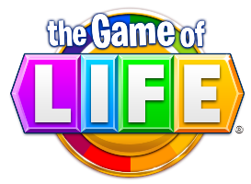
The Game of Life: Personal Finance Guidebook
Economics
Personal Finance Unit
Ms. Bennett

Directions: You will use the online website Padlet.com to showcase what you have learned during our Personal Finance Unit. This guidebook will serve as a guide for young adults 18-25 offering advice on how to be financially responsible. Please see the requirements and rubric below. If you need assistance in creating the Padlet, please go to my website msbennettmhvp.weebly.com, click on “Padlet in the Classroom and then on the “Padlet: A How-to Guide.”

Sample: Go to: http://padlet.com/ms_bennett1/Bananassample to view my sample! You may also go under “Padlet in the Classroom” to view samples.

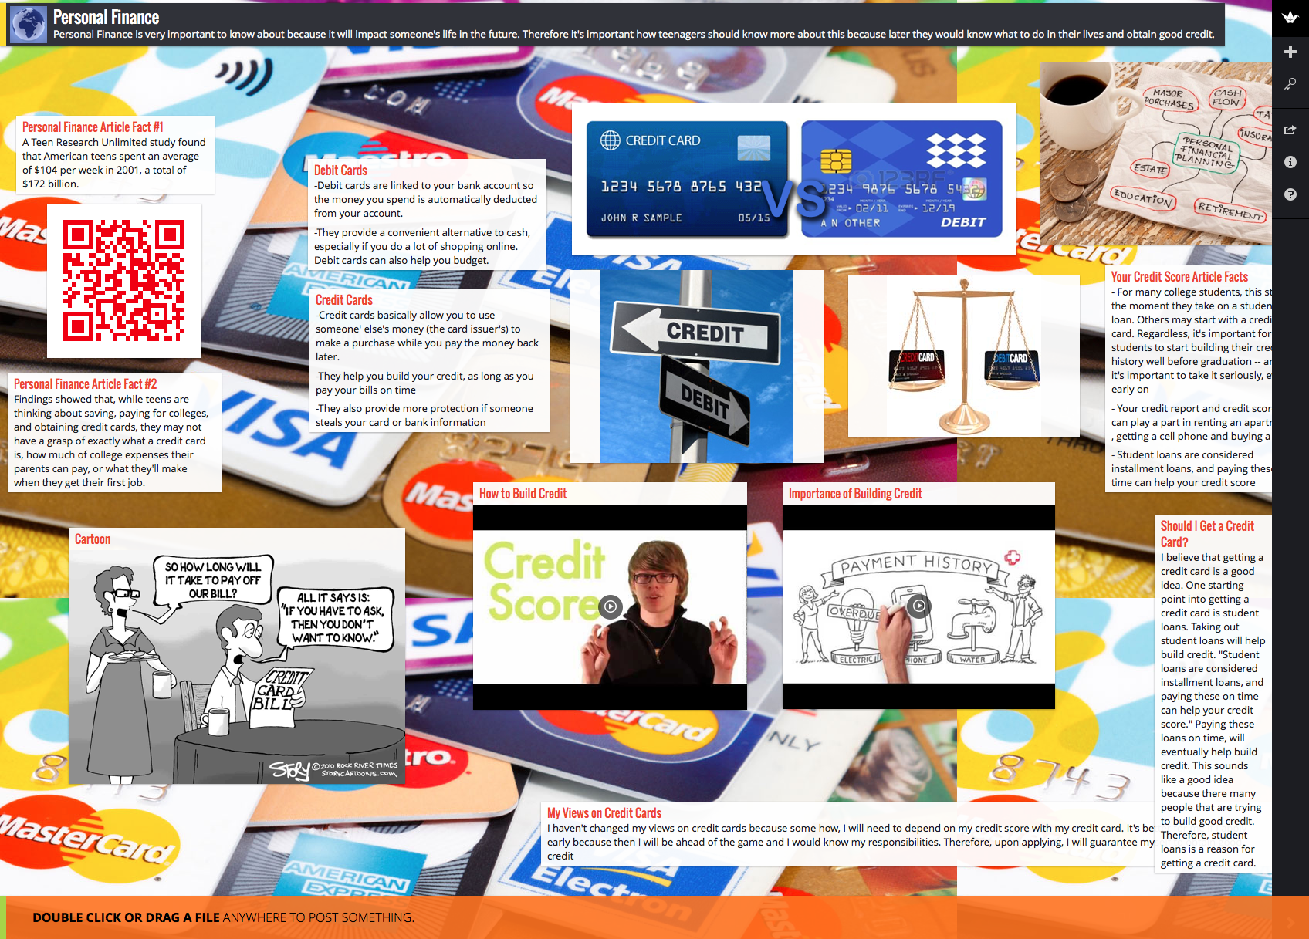

Requirements: Please include the following on your Padlet:

Minimum Requirements: Everyone Must Have
- A Title and Mini-description below (Title should be something like “Ms. Bennett’s Personal Finance Guidebook”)
- Definitions of personal finance and financial literacy in your own words
- Present 2 facts from the Article Teaching Gap: 83% of Teens Don’t Know How to Manage Money by Kathryn Tuggle. One fact should be a quote and commentary from the article
- 2 Facts comparing/contrasting debit/credit cards from the New York Times Article Credit and Debit Cards: What You Need to Know by Jennifer Barrett (New York Times)
- 3 Pictures for either personal finance or credit/debit cards
- 1 Additional picture of your choice

Additional Components: Approaching, Meeting, and Exceeding
Approaching | Meeting | Exceeding
Must Complete:  *Present one fact from Your Credit Score: After College, It’s the One Grade That Matters Most by Erin Lowry (DailyFinance.com)  *Argue in three or more sentences whether you think getting a credit card is a good idea. Cite one piece of evidence from the text (Lowry article listed above) to defend your  position.  *Argue in three or more sentences whether or not employers should have the right to check their prospective employees’ credit scores when hiring for positions. Cite one piece of evidence from the text (a quote from Bumpy Road for Bill to Ban Credit Checks for Job Applicants by Rachel L. Swarns).  *Choose THREE of the components listed below | Must Complete:  *Present two facts from Your Credit Score: After College, It’s the One Grade That Matters Most by Erin Lowry (DailyFinance.com)  *Argue in five or more sentences whether you think getting a credit card is a good idea. Cite one piece of evidence from the text (Lowry article listed above) to defend your position.  *Argue in four or more sentences whether or not employers should have the right to check their prospective employees’ credit scores when hiring for positions. Cite one piece of evidence from the text (a quote from Bumpy Road for Bill to Ban Credit Checks for Job Applicants by Rachel L. Swarns).  *Choose FOUR of the components listed below | Must Complete:  *Present three facts from Your Credit Score: After College, It’s the One Grade That Matters Most by Erin Lowry (DailyFinance.com)  *Argue in seven or more sentences whether you think getting a credit card is a good idea. Cite one piece of evidence from the text (Lowry article listed above) to defend your position.  *Argue in five or more sentences whether or not employers should have the right to check their prospective employees’ credit scores when hiring for positions. Cite one piece of evidence from the text (a quote from Bumpy Road for Bill to Ban Credit Checks for Job Applicants by Rachel L. Swarns).  *Choose FIVE or more of the components listed below

Additional Components:
- One visual/chart/picture about credit scores
- One video discussing how to build credit
- One video about the importance of building credit
- Two or more sentences about how the government has protected consumers in regards to credit cards (please include a link to your source)
- A range of potential interest/finance charges on a car loan based on your credit (please include a link to your source)
- A cartoon about credit cards/credit report/credit score
- Three or more sentences about how your views on credit cards have changed- will you apply for a credit score? Why/why not?
- Create a scenario: What would happen if you were 25 and in credit card debt of $2,000. Go to http://www.bankrate.com/calculators/managing-debt/minimum-payment-calculator.aspx and calculate the different amounts you would have to pay each month to pay that off in six months, one year, two years, and five years. and present the information in either a chart or sentence form.
- Discuss which bank/credit union you would open an account with and defend your position in 3+ sentences, with specific examples. Think back to the webquest we did when we searched for a bank/credit union.
- Go to https://www.mint.com/ and create a budget for yourself. Take a screenshot and post on your padlet.
EXTENSION:
Create a QR Code for your Padlet!
- Go to qrstuff.com and follow the instructions to create a QR code.
- For a tutorial on how to create a QR Code, go to my website under “Economics” and click on “Unit 3: Personal Finance.”
- Put the QR Code you created on your Padlet

Rubric: This grade is worth 90 Points
 | Somewhat (1) | Mostly (2) | Always (3)
Completion of Components | Some of the required components listed above are completed but many are missing. | Most of the required components above are completed, may be one or two missing. | All of the required components listed above are completed.
Quality of Information/ Accuracy | Little information is accurate and/or answers are incomplete. There are several spelling/ grammar errors on page. | Most information is accurate and answers are mostly complete. There are few spelling/ grammar errors on page. | All information is accurate and answers are complete. There are no spelling/ grammar errors on page.
Aesthetics | Padlet is somewhat appealing to the viewer and attractive to the eye. Colors somewhat go together well and some fonts/text are difficult to read. | Padlet is mostly appealing to the viewer and attractive to the eye. Colors mostly go together well and most fonts/text are visible and easy to read. | Padlet is appealing to the viewer and attractive to the eye. Colors go together well and all fonts/text are visible and easy to read.
Comments: Grade: _________/9 x 10= _____/90

