HOW TO WRITE AN ESSAY

INTRODUCTION

- Start with a broad, non-controversial introductory sentence that puts the reader in the ballpark of the essay. Avoid questions and quotations as your first sentence; this should be a declarative sentence.
- The next two or three sentences develop on the first sentence, adding increasingly more specific information leading up to the thesis statement.
- The last sentence of the Introduction is the thesis statement. The thesis statement unequivocally states your side of the argument, or the main point of the essay, and provides “a roadmap” or outline for the rest of the essay.

What you plan to argue + How you plan to argue it = Thesis

BODY PARAGRAPHS
- Strong assertion or topic sentence. What will this paragraph be proving? What is its goal?
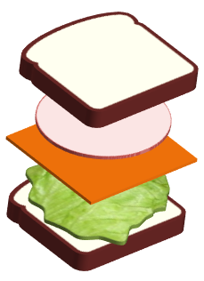
  - Top layer of Bread – Introduction of the quotation that responds to your claim (Mr. Lamb calls this Intro to Ev.)
  - Peanut Butter – The lead-in to the quotation (e.g. "According to," "Kincaid writes," etc.)
Quote
Sandwich
  - Jelly – The quotation itself. This can be a whole sentence or just a few words taken from a text. It could even be a paraphrase.
  - Bottom layer of Bread – Commentary or explanation of the quotation in the context of your argument.
- The wrap-up. This sentence connects your reason back to your thesis statement. All roads lead back to Rome (or your thesis statement)

PLEASE NOTE!! A body paragraph can have many quote sandwiches within it. You’ll need one sandwich for each quote.

CONCLUSION

A good conclusion reverses the process of the introduction. I start with a specific sentence (a restatement of your thesis, and finish with a broad statement to wrap it up. It should have:
- Restate the thesis in a new way (Don’t repeat your thesis word-for-word).
- Present one or two general sentences which accurately summarize the arguments that support the main thesis.
- End the essay with a statement that illustrates the point of the essay (Basically answers the question: So what? What is my essay about? What am I saying?). Suggestions for ending sentences are ending with a bit of irony, making an appeal to the reader’s emotions, or calling the reader to action.

