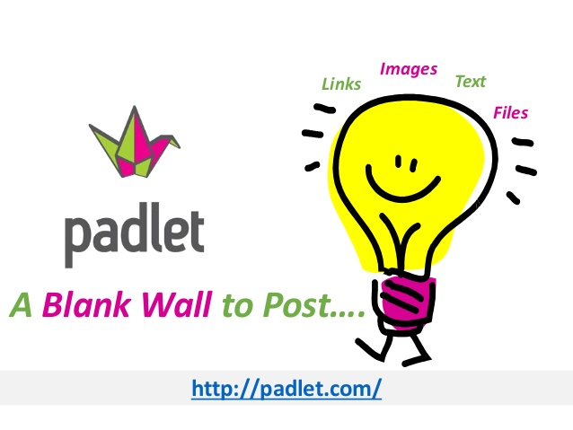
My Guidebook to Politics: Part 1
Government
Rights & Responsibilities Unit

Directions: You will use the online website Padlet.com to showcase what you have learned during our Rights and Responsibilities Unit. This guidebook will serve as a guide for young adults 18-25 offering advice and information about politics. Please see the requirements and rubric below. If you need assistance in creating the Padlet, please go to my website msbennettmhvp.weebly.com, click on “Padlet in the Classroom” and clisk on the document under “Padlet: A How-to Guide.”

Sample: Go to: http://padlet.com/ms_bennett1/Bananassample to view my sample! You may also view samples under the “Padlet in the Classroom” page.

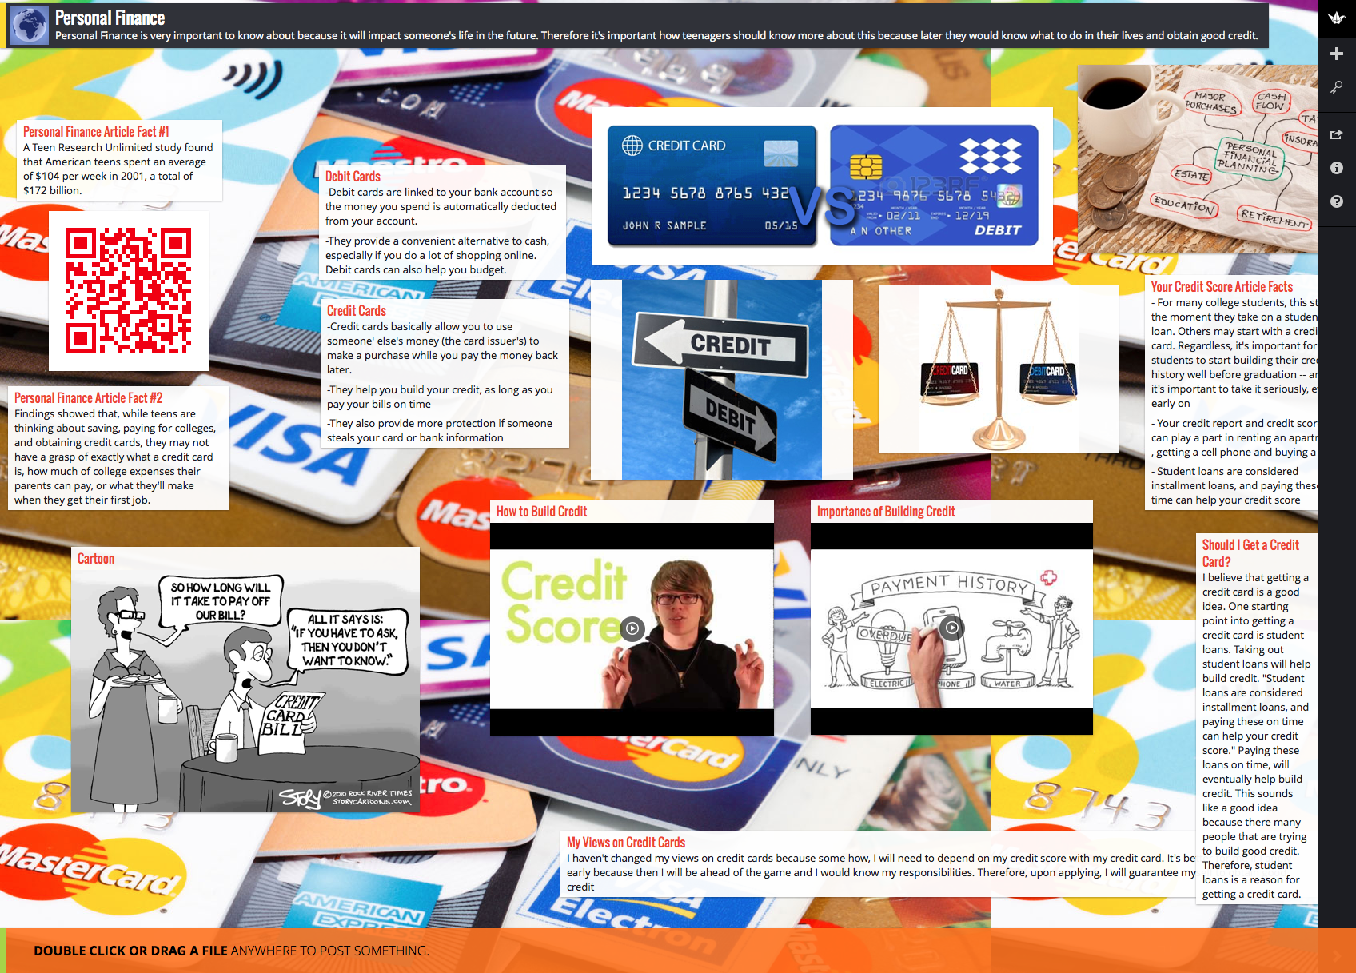

Requirements: Please include the following on your Padlet:

Minimum Requirements: Everyone Must Have
- A Title and Mini-description below (Title should be something like “Ms. Bennett’s Guidebook to Politics”)
- Definitions of political and political socialization in your own words
- List/explain the four agents of political socialization
- Present 2 facts from the Article How Family Communication Can Influence Our Political Identities by Lindsay Hoffman.

***Today we are completing the minimum components of this assignment. When students finish Part 1, they can move on to complete additional components. There are two listed below but see the separate document assignment for additional components.

Additional Components:
- One visual/chart/picture about political socialization
- One video discussing the agents of political socialization
Rubric: This grade is worth a 63 Point Quiz Grade
 | Somewhat (1) | Mostly (2) | Always (3)
Completion of Components | Some of the required components listed above are completed but many are missing. | Most of the required components above are completed, may be one or two missing. | All of the required components listed above are completed.
Quality of Information/ Accuracy | Little information is accurate and/or answers are incomplete. There are several spelling/ grammar errors on page. | Most information is accurate and answers are mostly complete. There are few spelling/ grammar errors on page. | All information is accurate and answers are complete. There are no spelling/ grammar errors on page.
Aesthetics | Padlet is somewhat appealing to the viewer and attractive to the eye. Colors somewhat go together well and some fonts/text are difficult to read. | Padlet is mostly appealing to the viewer and attractive to the eye. Colors mostly go together well and most fonts/text are visible and easy to read. | Padlet is appealing to the viewer and attractive to the eye. Colors go together well and all fonts/text are visible and easy to read.
Comments: Grade: _________/9 x 7= _____/63

